OPERATING SYSTEM LAB TASK 3

NAME: SYED MUZZAMIL WASEEM

SID: 11067

CID: 109134

QUESTION 1:

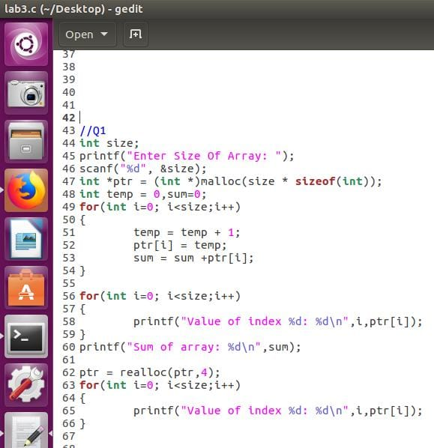

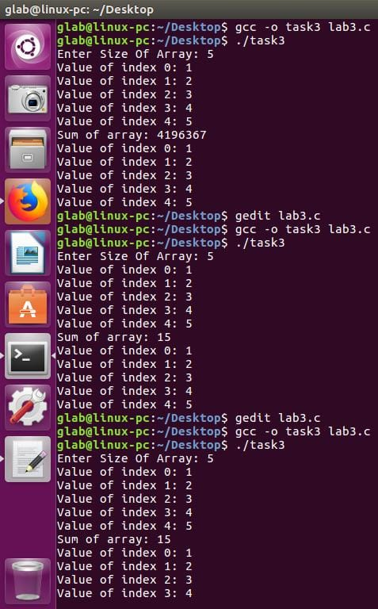

QUESTION 2:

